What are "warm" and "cool" colors? What different feelings do they evoke?
Warm colors are colors like red, orange, and yellow. They are supposed to be eye catching and ‘evoke warmth, energy, and stimulation’ (https://www.landingpageflow.com/post/which-performs-better-warm-vs-cool-color-psychology). This is because people often associate these colors with fire and sunlight.
Cool colors are colors like blues, greens, and purples. Cooler tones ‘create a soothing atmosphere, reduce visual tension, and build a sense of reliability’ (https://www.landingpageflow.com/post/which-performs-better-warm-vs-cool-color-psychology). This is because people associate cool tones to water, sky, and calm.
How does a color's effect change depending on the other colors nearby?
A color’s appearance can change depending on if it is near other colors because color perception creates an effect that maybe a warm color may appear warmer when its placed next to a cool color and vise versa. You can also make people feel different ways when clashing colors together. For example using complimentary colors creates a “clashing” effect creating a contrast of colors that catches the eye. There also is simultaneous contrast in which the values of having a dark background can effect how you view the subject as it may appear lighter. (https://ipoxstudios.com/complementary-colors-the-biggest-myth-of-all-time-video/ )
What are some examples of the cultural differences related to color and meaning?
One example of the cultural differences related to color is the differences in the opinion on the color red. In India the color red is associated with purity and they wear red wedding dresses while in the US the color of purity is white. In our culture on the western side, we see red as a color meaning danger, love, or urgency. Red is also prominent in many religions and in Asia it is associate with luck and fortune. These are all examples on how cultural differences change the meaning of color and how it is important to know your target audience for creating appealing websites. (https://eriksen.com/marketing/color_culture/ )

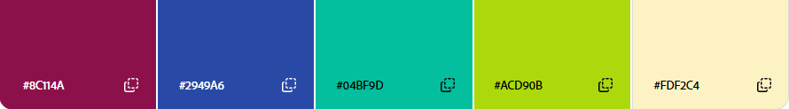
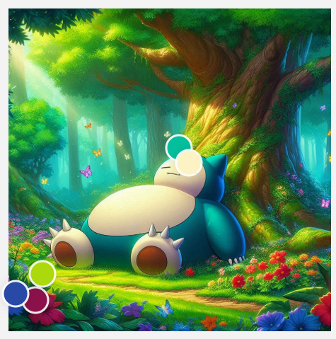
Mood: Calm and a cozy sleepy atmosphere that makes the view feel cozy.

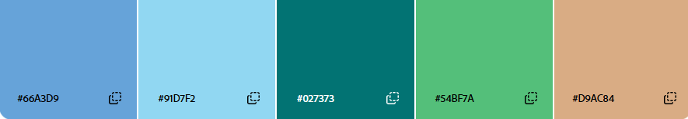
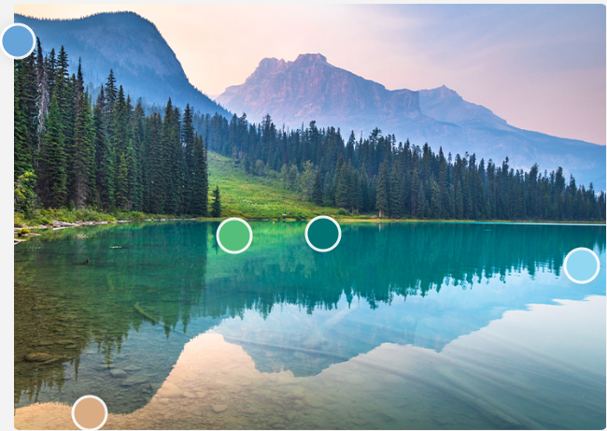
Mood: Cooler color calm open water to create a mood of peace and calmness.

Mood: The mood of this image is very calm while also introducing some pastel colors to make the sky pop a little extra. It also mimics cotton candy.
